Viking Hathor and Viking Sobek Naming
Photo Captions
11/5/24


- Viking today named its newest river ships, the Viking Hathor and Viking Sobek, with a celebration in Luxor, Egypt. Designed specifically to navigate the Nile River, the state-of-the-art ships were built at the Massara shipyard in Cairo and will sail Viking’s popular Pharaohs & Pyramids itinerary. Pictured here, the Viking Hathor and the Viking Sobek at Viking’s premier docking location at the Karnak Temple in Luxor, Egypt. For more information, visit www.viking.com.

- Viking today named its newest river ships, the Viking Hathor and Viking Sobek. Pictured here, British photographer Alastair Miller, serving as master of ceremonies for the naming of the Viking Hathor and the Viking Sobek in Luxor, Egypt. For more information, visit www.viking.com.


- Torstein Hagen, Chairman and CEO of Viking, speaks during the naming ceremony of the Viking Hathor and the Viking Sobek in Luxor, Egypt. For more information, visit www.viking.com.
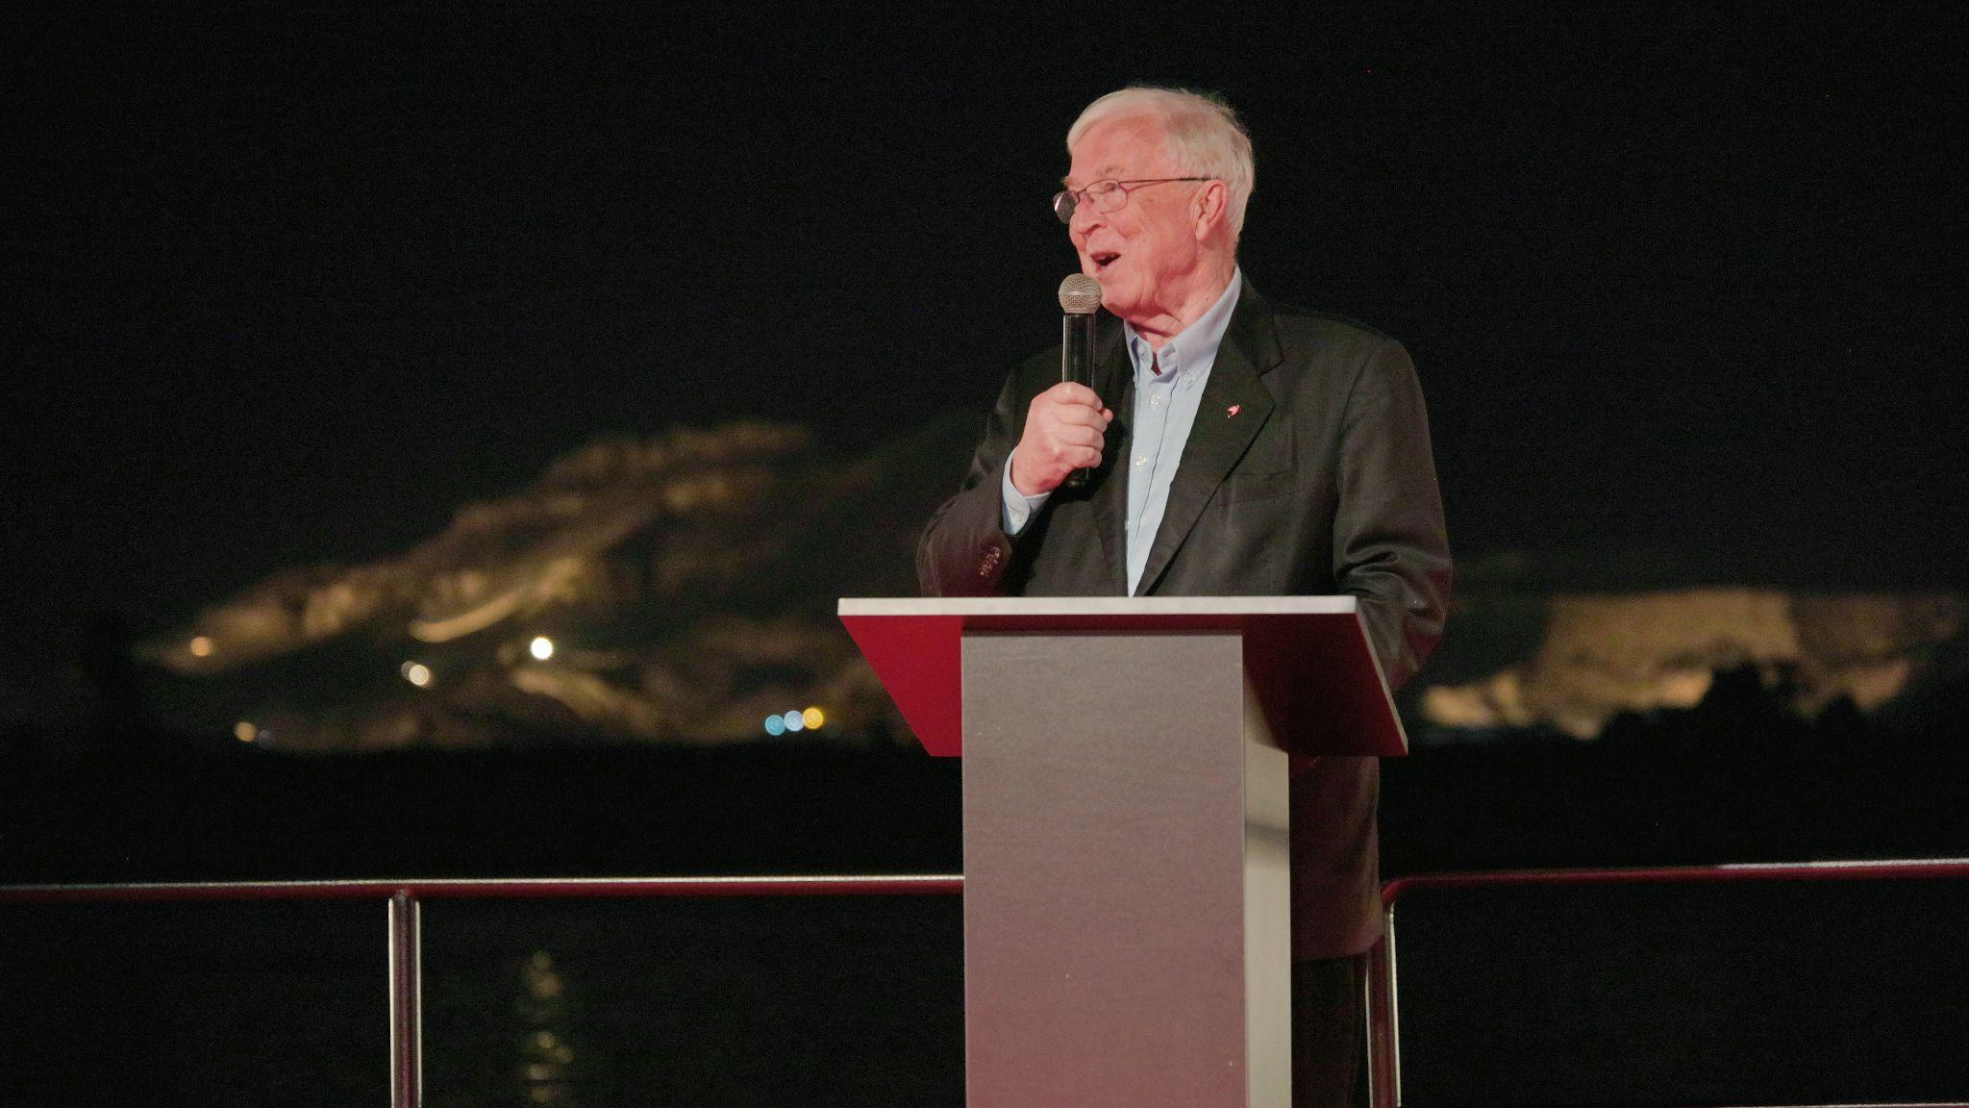

4. The Hon. Edward Herbert names the Viking Hathor during a ceremony in Luxor, Egypt on November 5, 2024. Edward’s great-great-grandfather, the 5th Earl of Carnarvon, was Howard Carter’s benefactor and co-explorer, whose excavation uncovered the tomb of King Tutankhamen near Luxor almost exactly 102 years ago on November 4, 1922. For more information, visit www.viking.com.



- Mohamed El Banna, founder of Cosmos Egypt and a member of the Egyptian Senate, names the Viking Sobek during a ceremony in Luxor Egypt on November 5, 2024. For more information, visit www.viking.com.



- Torstein Hagen and Karine Hagen with Egyptian officials and members of the extended Viking family at the naming ceremony of the Viking Hathor and the Viking Sobek in Luxor, Egypt. For more information, visit www.viking.com.


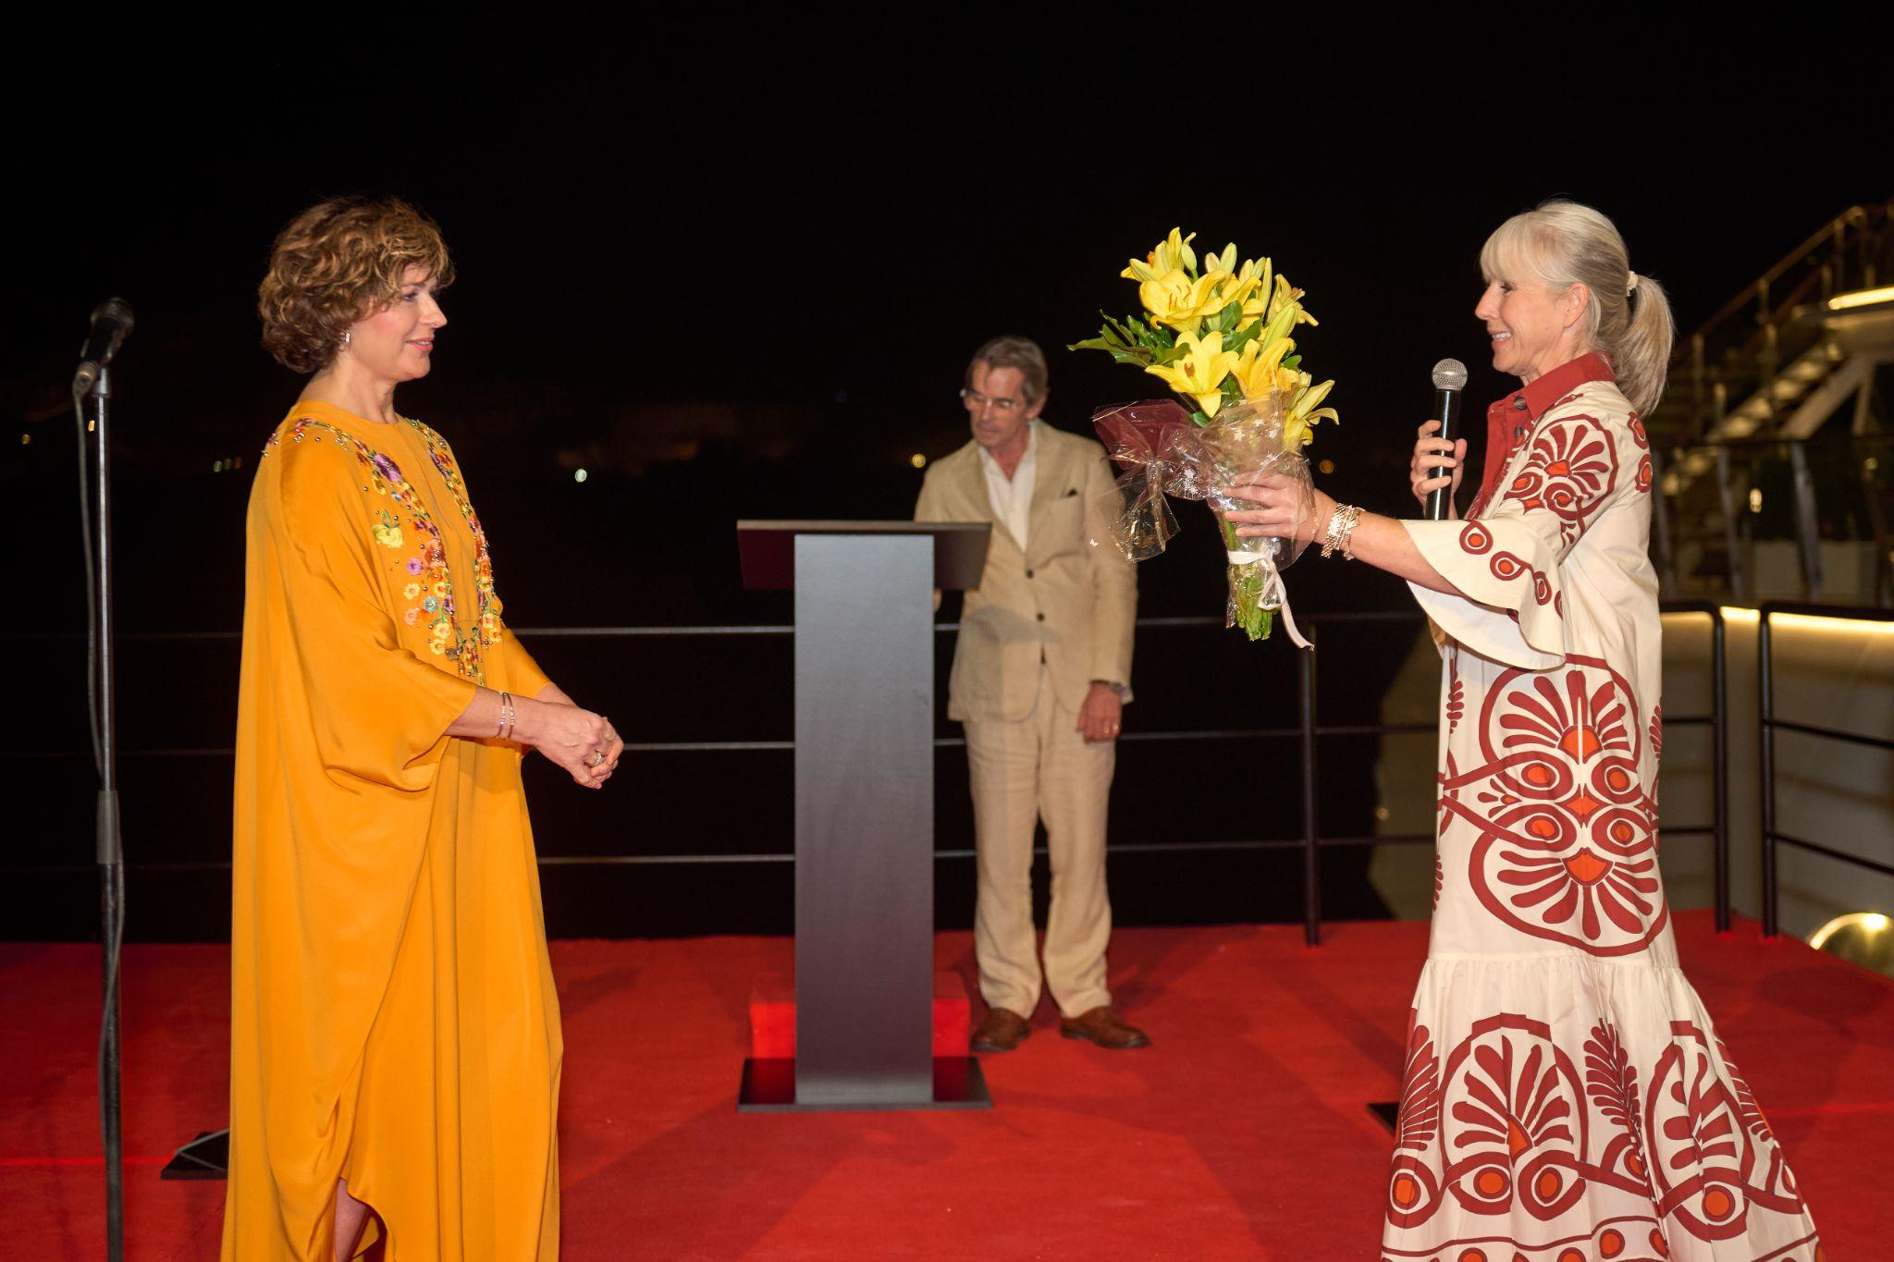
- Viking “godsisters” Karine Hagen and Sissel Kyrkjebø at the naming of the Viking Hathor and the Viking Sobek in Luxor, Egypt. For more information, visit www.viking.com.

- Pictured here, a harpist performs during the celebratory dinner inside the nearby Karnak Temple following the naming of the Viking Hathor and the Viking Sobek in Luxor, Egypt. For more information, visit www.viking.com.
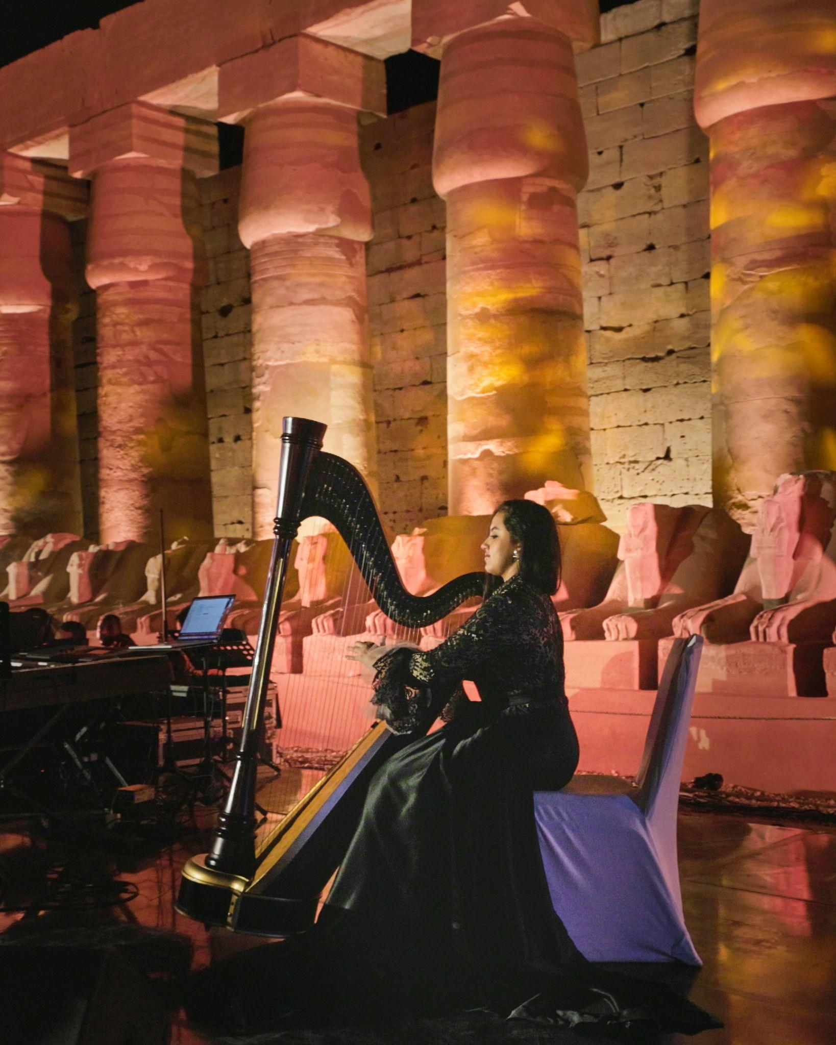

- Pictured here, Norwegian singer Sissel Kyrkjebø, one of the world’s leading crossover sopranos and godmother of the Viking Jupiter, performs during the celebratory dinner in the nearby Karnak Temple following the naming of the Viking Hathor and the Viking Sobek in Luxor, Egypt. For more information, visit www.viking.com.
