Press Release, Reputation and Trust Analytics
EMBARGO 26.2.2026

Mobile payment services rose to the top in reputation across all Nordic countries

The Financial Sector Reputation&Trust 2025 study conducted by Reputation and Trust Analytics reveals that mobile payment services have risen to the top in reputation across all Nordic countries. In Norway, Vipps gains the highest reputation score across the Nordics.

Reputation and Trust Analytics' Financial Sector Reputation&Trust 2025 study examined the reputations of a total of 103 companies in Finland, Sweden, Norway, and Denmark. In all four countries, mobile payment services received the best reputation scores.

In Finland and Denmark, MobilePay was rated best, while in Norway, it was Vipps. In Sweden, the country's own payment service, Swish, rose to the top as the most reputable.

Denmark-founded MobilePay and Norwegian-origin Vipps merged in 2022, and in 2024 they combined their services onto the same platform.

"Nordic people clearly value the ease of payment that these services offer. Payment services received higher ratings in all four countries than traditional banks or insurance sector operators," says Harri Leinikka, CEO of Reputation and Trust Analytics.

The highest reputation score was Vipps in Norway, at 4.13. MobilePay's scores in Finland and Denmark were 3.86 and 3.83, respectively. Swish received a reputation score of 3.78 in Sweden.

"Norwegians clearly value Vipps the most. In Sweden, however, Vipps falls behind Sweden’s own Swish service; Vipps' reputation in the country is at a moderate level," Leinikka notes.

In the Reputation&Trust model, each organization is assigned a reputation score on a scale of 1–5. An organization's reputation is at an excellent level if its reputation score is at least 4. The reputation is at a good level if the score is between 3.50 and 3.99.

Denmark has the strongest central bank reputation in the Nordic region

When examining the results from all four countries, it can be seen that among local central banks, Danmarks Nationalbank receives the best reputation score, 3.72. Norges Bank's reputation score of 3.58 also reaches a good level.

The Bank of Finland's reputation score of 3.37 and Sveriges Riksbank's 3.26 are at moderate levels.

"In our Nordic comparison, Danish and Norwegian citizens trust their central banks significantly more than their Finnish and Swedish counterparts. The Danish central bank was the only one in the group to receive excellent ratings for leadership. However, the biggest differences emerge from how citizens perceive their central bank's success in its role,” Leinikka states.

The most reputable companies in the Nordics

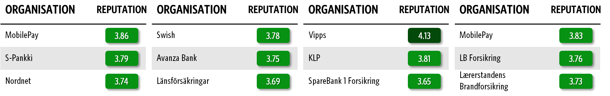

TABLE: The Financial Sector Reputation&Trust 2025 study. The most reputable companies in the financial sector in Finland, Sweden, Norway, and Denmark. Please find attached the full list of companies examined in Norway.

Insurance companies follow Vipps on the scoreboard

In Norway, the top position retaining Vipps is the only company in the financial sector with a very good reputation. Insurance companies—both within life/pensions and non-life—generally enjoy stronger reputations than banks, with KLP, SpareBank 1 Forsikring, Gjensidige, and Storebrand all with solid overall reputation measures.
More than half of the companies in the sector have a good overall reputation, and among those with an overall moderate reputation, we find some of the larger pan-Nordic operators such as Tryg, If, and Nordea.

The financial sector’s reputation structure in Norway

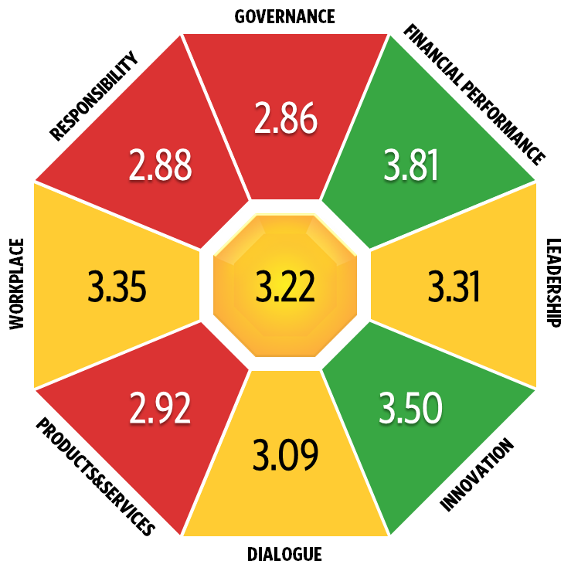
PICTURE: The Financial Sector Reputation&Trust 2025 study. The financial sector’s reputation in Norway measured on eight dimensions: corporate governance, finance, management, innovation, interaction, products & services, workplace, and responsibility.

The reputation of the financial sector is moderate overall, reaching an aggregate score of 3.22 on a five-point scale of the Reputation&Trust study.
The industry performs strongest in the reputation dimensions Financial Performance and Innovation, where it is viewed as a sector with solid economic resilience and strong developmental capacity.
The most pronounced development areas, however, are found within Governance and Responsibility. This indicates a more critical stance toward transparency and governance, as well as a perception that the financial sector does not fully meet expectations regarding societal responsibility.
"Norway was the only country where citizens perceived the financial sector as renewing and developing. In Sweden, Finland, and Denmark, perceptions remained at only a moderate level. But according to the analytics, the most important reputation dimensions for building trust are transparency, responsibility, and value for money,” says Fredric Hammarström, Senior Advisor at Reputation and Trust Analytics.

How we conducted the research

The goal of the Financial Sector Reputation&Trust 2025 research was to examine the reputation of companies operating in the Nordic countries general reputation of the sector among citizens. Data collection was carried out through an electronic survey in Finland, Sweden, Norway, and Denmark from 21.11. to 31.12.2025.

Organizations were evaluated using Reputation and Trust Analytics' Reputation&Trust research model, where an organization's reputation score is formed as an average of eight different areas. The areas are corporate governance, finance, management, innovation, interaction, products & services, workplace, and responsibility. The study used a five-point rating scale (1–5).

A total of 12 305 people from Finland, Sweden, Norway, and Denmark participated in the study. The target group in each country consisted of citizens aged 15–65 nationwide (in Finland, excluding Åland). The sample was weighted to represent each country’s population by gender, age, and region of residence.

For more information:
Harri Leinikka, Reputation and Trust Analytics, CEO, +358 40 505 5001, harri.leinikka@reptrust.com
Fredric Hammarström, Reputation and Trust Analytics, Senior Advisor, +46 (0) 70 841 41 19, fredric.hammarstrom@reptrust.com

